Git.Art

**Creativity 2.0: from social network to online market**

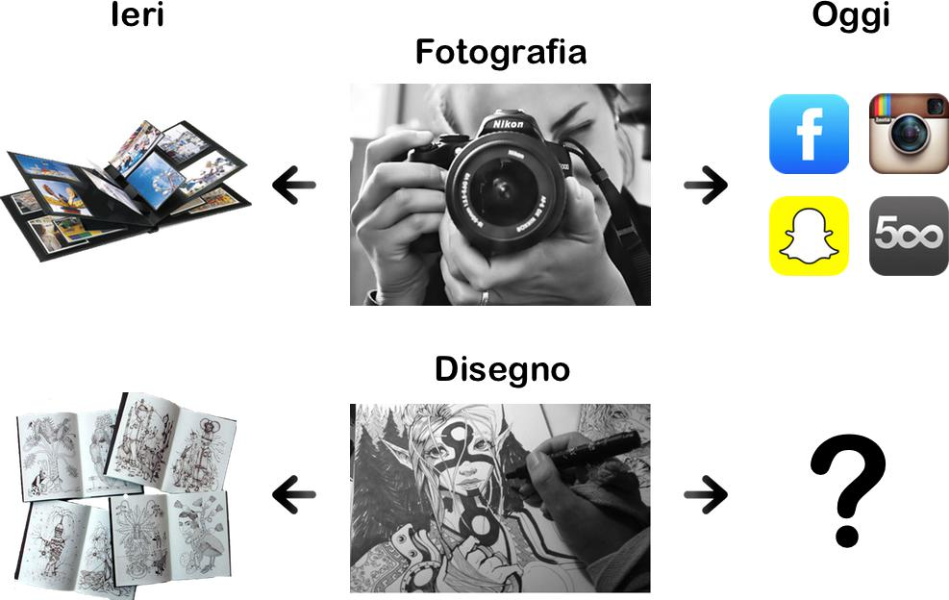

The Internet is full of photos, but not drawings.

Nevertheless, we can easily understand the importance of drawings through merchandising: t-shirts, posters, phone cases, pillows, greeting cards, stickers, notebooks, calendars, toys, comics and characters, etc.

How could we develop this market in a centralized and digital way?

There is no effective social network for hand drawings.

Page 1 of 7

{ questa immagine la volevo diversa. vorrei mettere qualcosa che completi la prima, come un sfondo o un secondo personaggio collegato al primo }

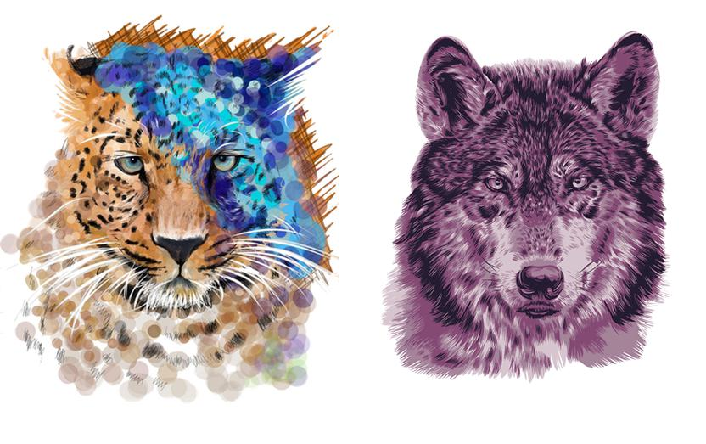

Drawings can be more social than any other content .

When you see a beautiful picture taken from a friend, all you can do is watch and comment on it. But if he passes you one of his drawings, you can take some pens and complete the work.

A Social Network of drawings allows its users to cooperate in a creative way.

Users will be able not only to leave comments or share content, but also to intervene on a friend’s drawing or draw inspiration from it in order to create their own digital works.

Page 2 of 7

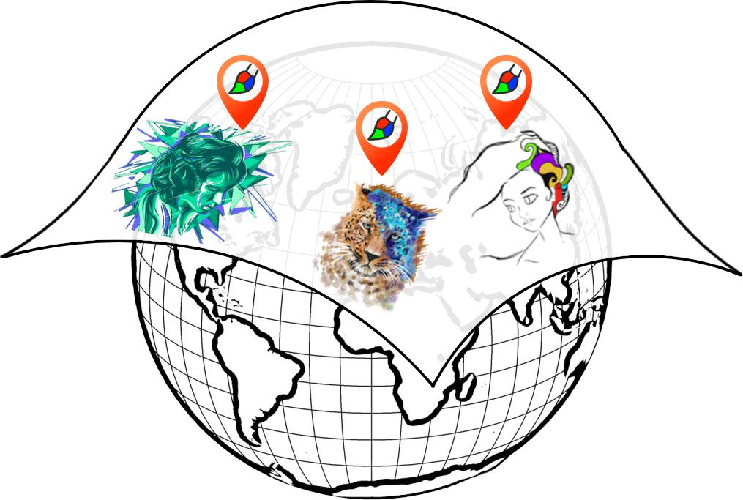

A 2D virtual realty that can be explored in the same way as Google Maps.

A single sheet of paper that will be shared and edited by all its users, who will be able to draw directly in-app or through an integrated editor.

Digital drawing can be extremely realistic even using a touch screen. Moreover, the GPS will allow us to take into the real world what we would normally do on our desk at home.

The aim is to virtually lay a blank sheet of paper on the whole world where users can geolocate their drawings.

Page 3 of 7

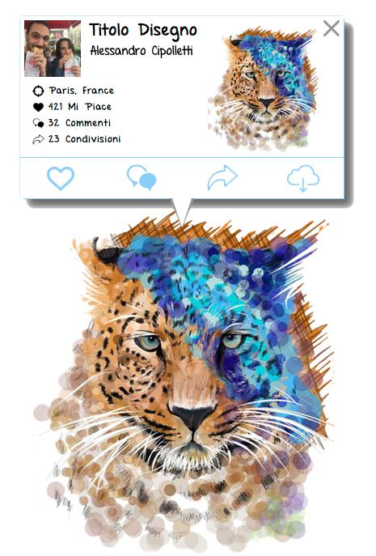

Every drawing will be uploaded singularly, thus allowing us to know which drawing has been clicked and show the number of likes, comments as well as the author’s name.

Users can at any time search by keywords or hash tag, see their friends’ favorites and what is popular around them.

From the drawer’s profile page it will always be possible to view all the drawings uploaded until then, along with the link to see them gelocated.

Profile pages, like buttons and comments, drawings titles and descriptions, as well as the possibility to get an activity stream based on your favorites.

Page 4 of 7

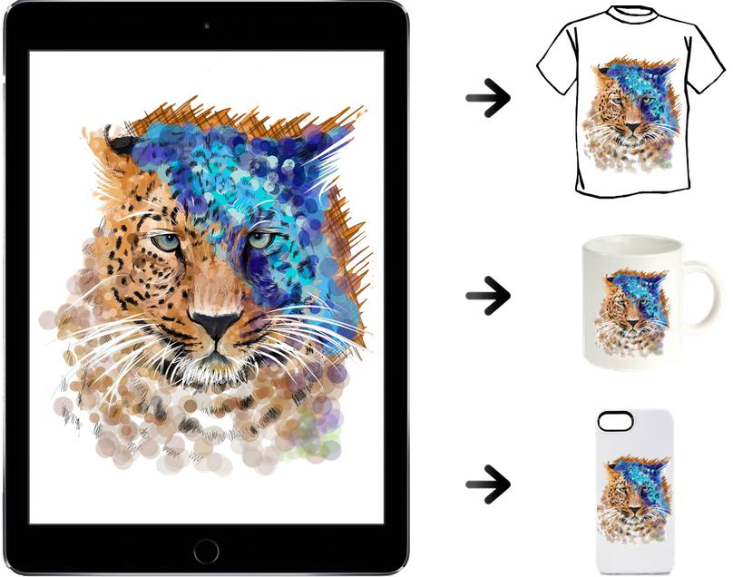

Possibility to buy many items printed with the desired drawing directly on the app.We will select some commercial partners among the hundreds of online services that allow you to buy personalized items and we will share part of the profits with the artists.

If the price for printing a cheap t-shirt online is 10 euros, users will be happy to pay 15 euros knowing that its quality will be the same for every user and that a part of the amount will be given to the followed artist.

Moreover, every t-shirt or gadget will simply further enhance our advertising, thus creating a brand.

Page 5 of 7



**Project Planning**

|  |  |  |  |  |
| --- | --- | --- | --- | --- |
| **ALPHA** | **BETA** | **PUBLIC** | **FUTURE** |  |
| Private | Public - Dev |  |  |  |
|  |  |  |  |  |
| **E**ditor 1.0 | User profile pages | Personalised activity stream | Native Mobile App |  |
| **D**ashboard 1.0 | Geolocation | Design interface | Zoom Social (**D** 2.0) |  |
| **B**ackend 1.0 | Image data cache (**D** 1.5) | WebApp Mobile | Fb Twitter Pinterest |  |
| Facebook Login | Enabled touch | Usage statistics | Credits per like / views |  |
|  | Performance bugfix | +2 editor tools (**E** 1.5) | **E-shop** |  |
|  |  | Backend security (**B** 1.5) |  |  |
|  |  | Google Login |  |  |
|  |  | Blog |  |  |
|  |  |  |  |  |
| " | 2 months | 6 months | " " " |  |
|  |  |  |
|  |  |  |  |  |



Page 6 of 7

Git.Art

Demo Alpha:

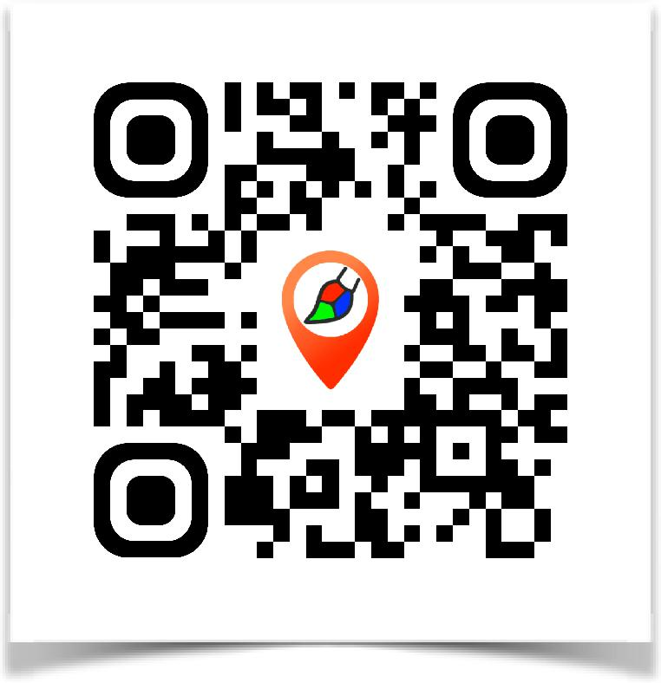

Alessandro Cipolletti Riccardo Gallotti

Page 7 of 7